CHAPTER – 2
Name: Ramya S S
Regno: 192421226
Course: CSA0609 – DAA
EXPERIMENT – 1
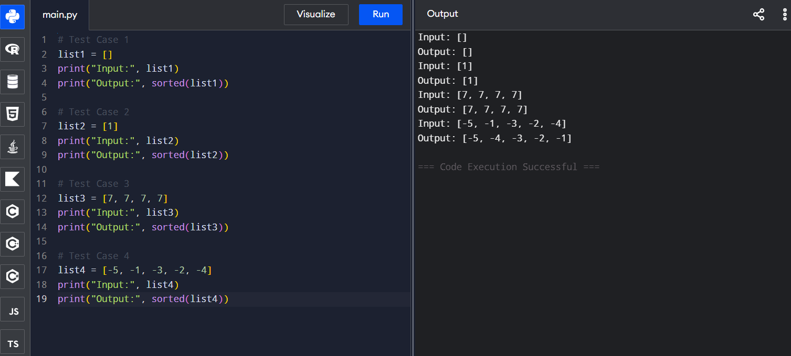
EXPERIMENT – 2
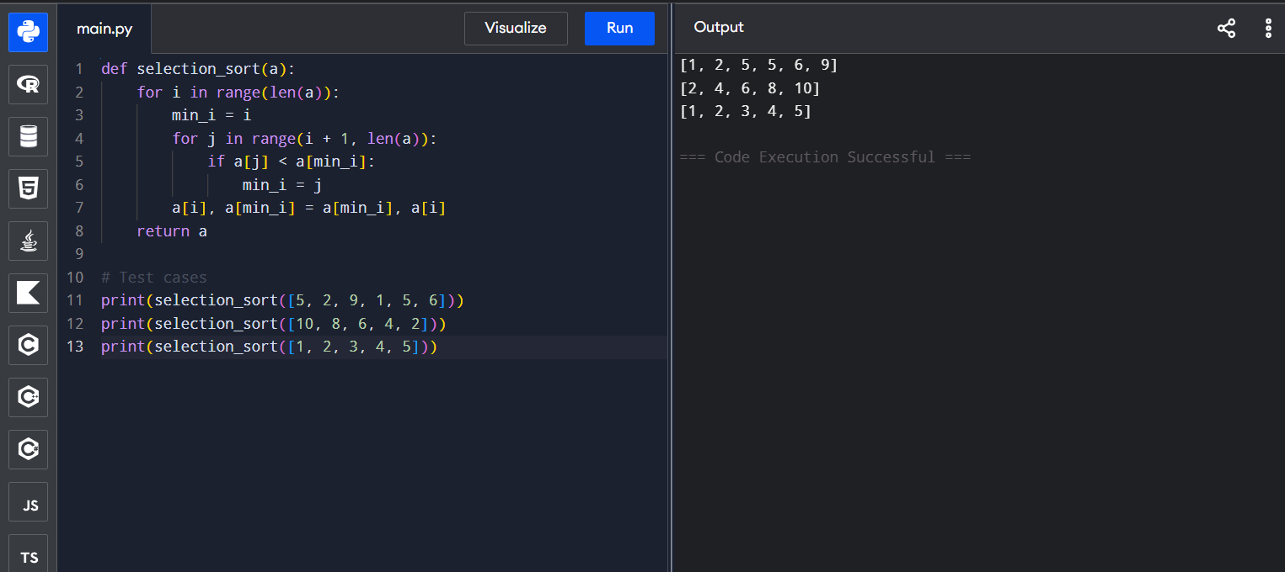

EXPERIMENT – 3
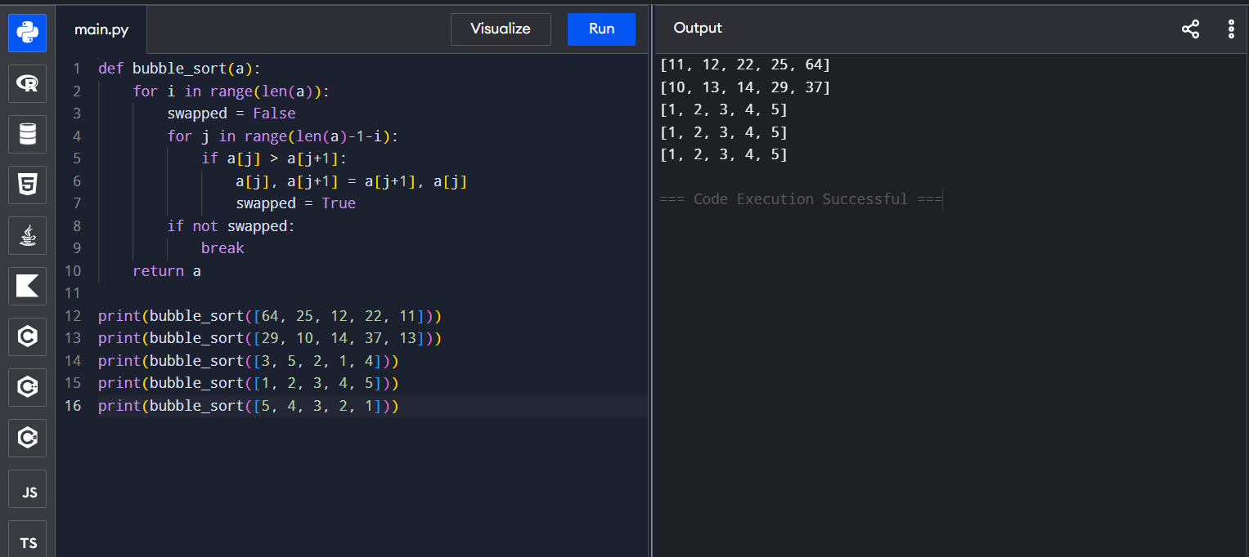
EXPERIMENT – 4
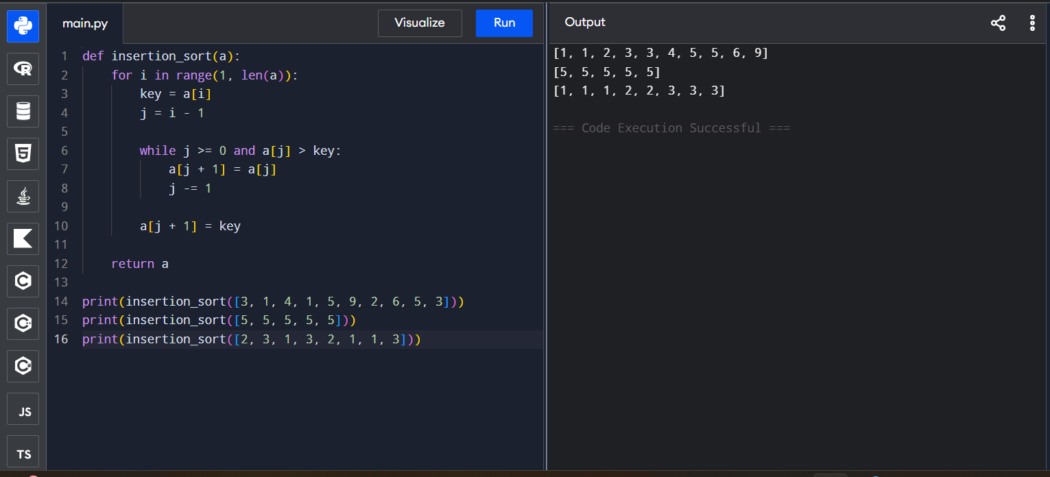
EXPERIMENT – 5
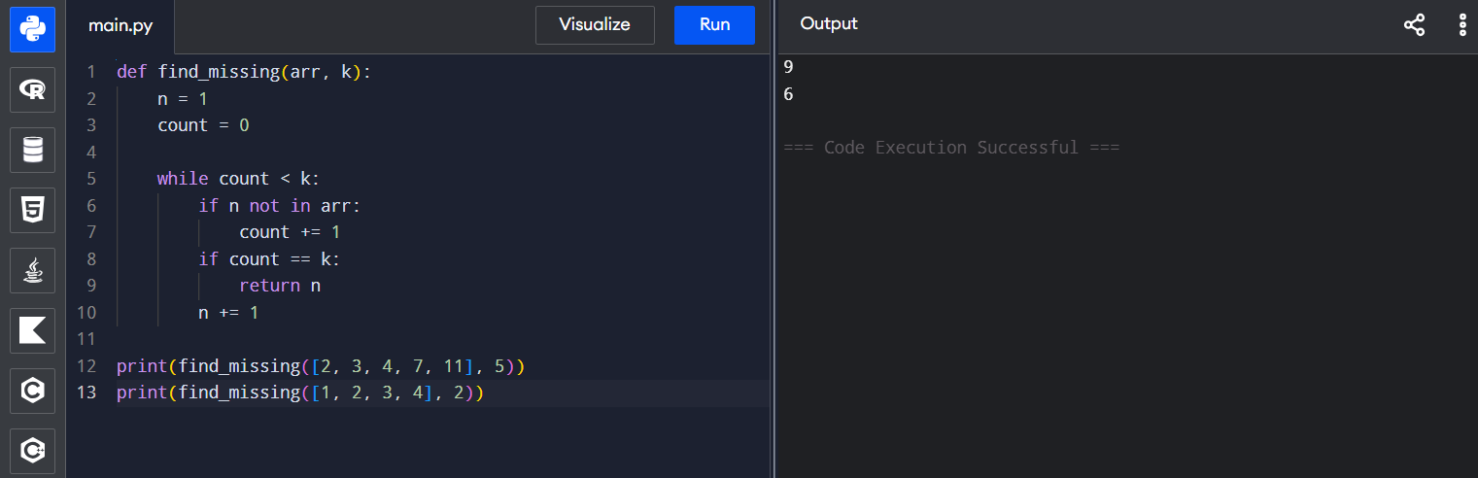

EXPERIMENT – 6
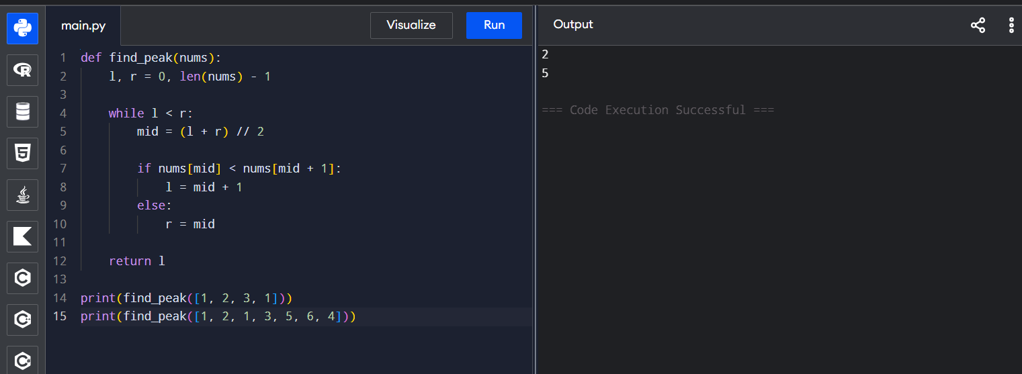
EXPERIMENT – 7
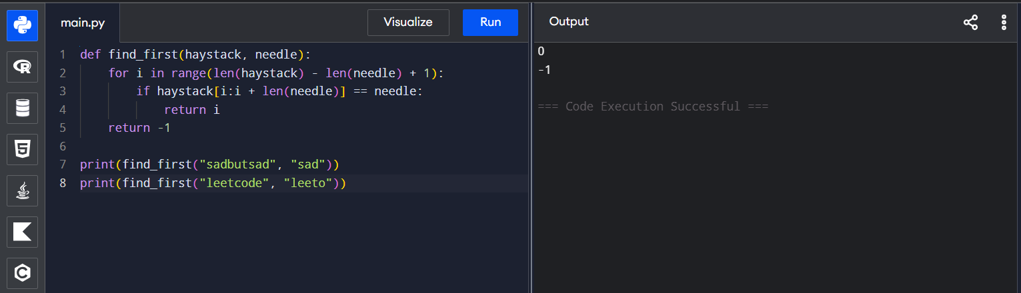
EXPERIMENT – 8
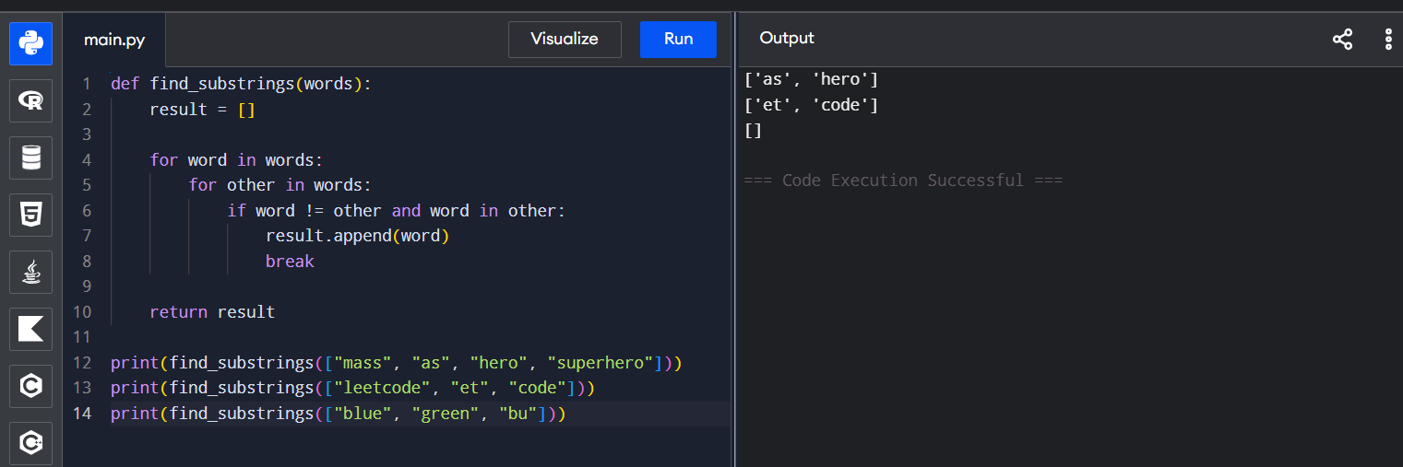

EXPERIMENT – 9
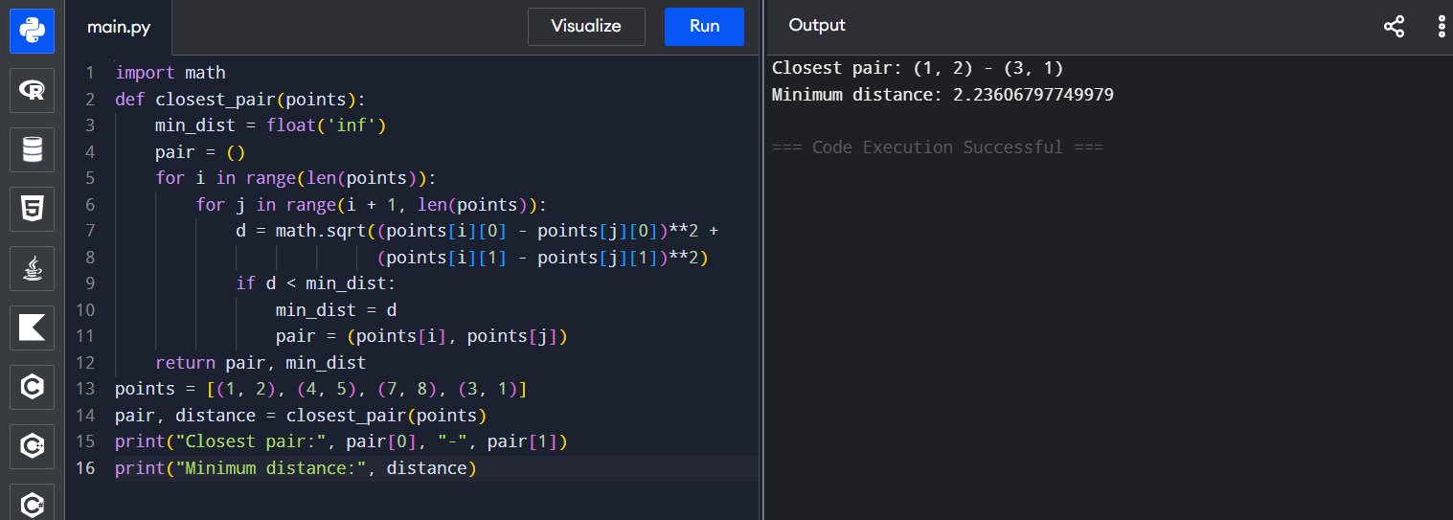
EXPERIMENT – 10
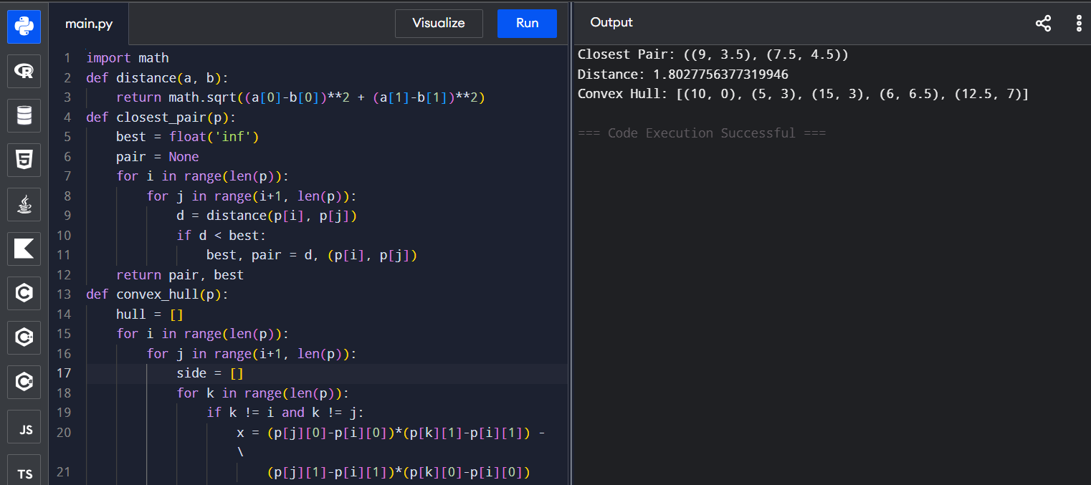
EXPERIMENT – 11
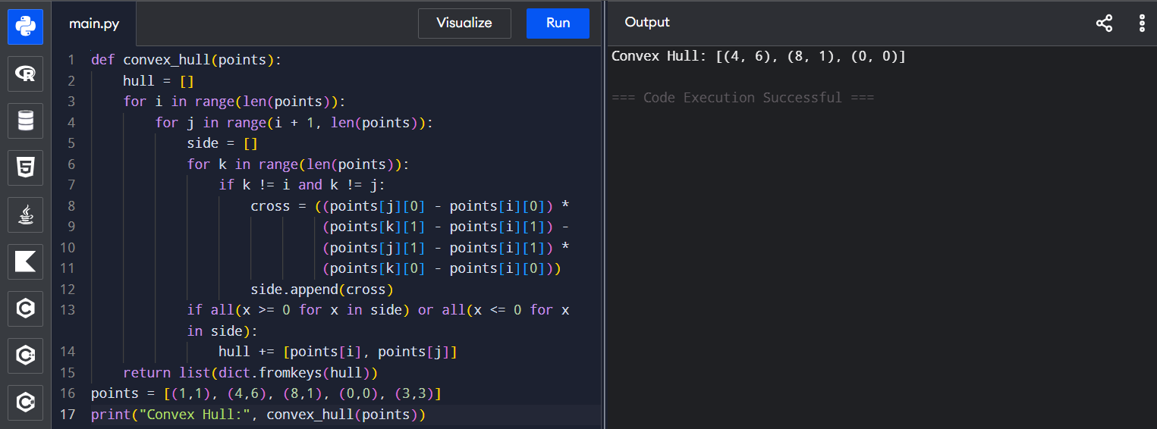

EXPERIMENT – 12
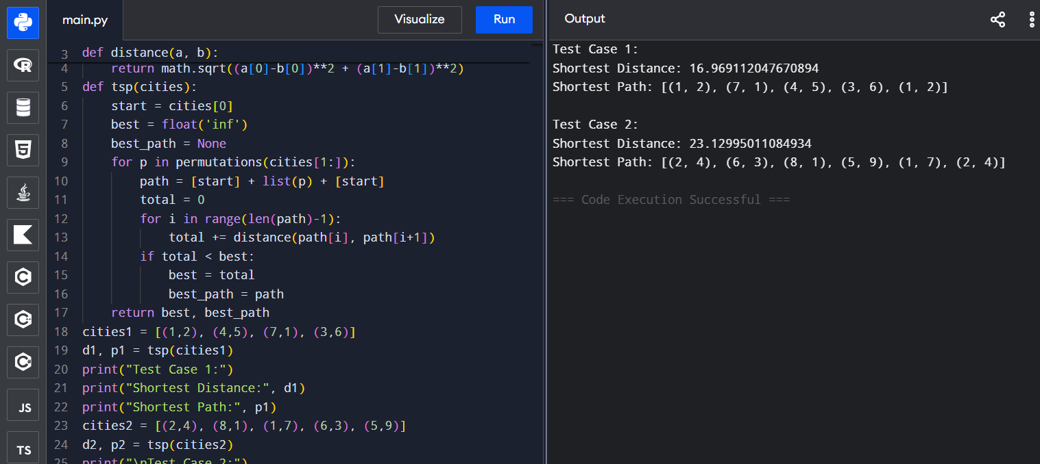
EXPERIMENT – 13
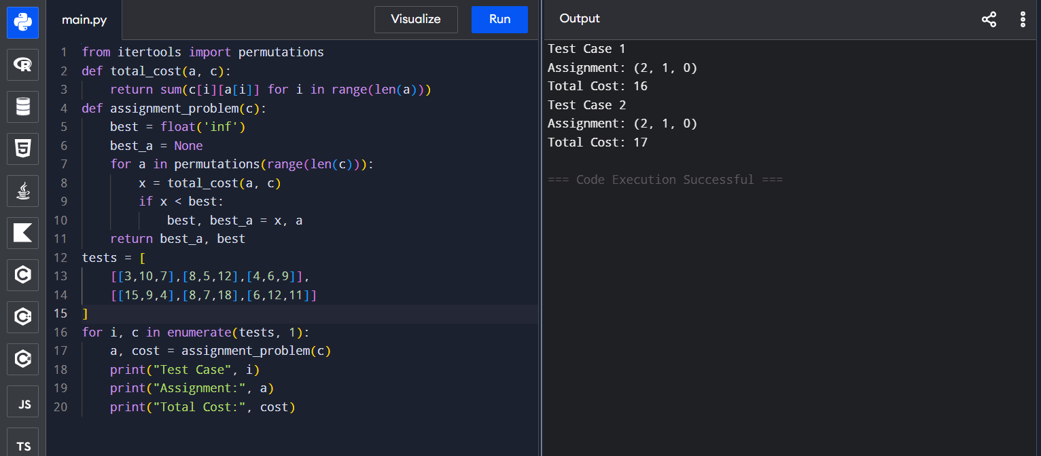
EXPERIMENT – 14
